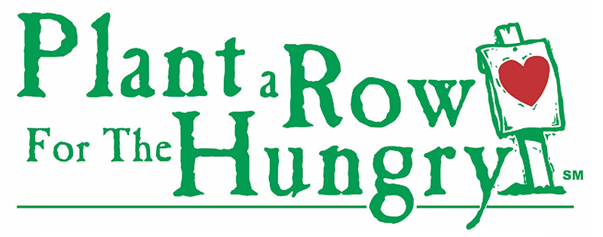
  - Thank You!
  - Thank you so much for becoming a Plant-A-Row member. We are so grateful for your help in feeding the hungry in our community!

  - Grow Your Veggies, Fruits or Herbs
  - Did you know there is no minimum or maximum required to donate? You can donate 1 pound or you can donate 1,000 lbs. All donations are 100% tax deductible. We are grateful for any and all produce that comes through our doors.

  - Helpful Hints for Packaging Produce
- Please try to keep like items together (lettuces, herbs, leafy veggies)
- Boxes are the best way to pack produce, but we accept produce in all types of packaging
- If using plastic bags to donate your produce, please make sure there are no holes or rips in the bag
- Unless you are packaging herbs, please do not seal plastic bags (it traps the moisture and encourages decomp of the veggies)
- Mind the tomatoes! Please separate heavier fruits and veggies from the lighter ones. Bruising happens!

  - Drop Off Your Produce – We Now Have Two Locations
- You can bring your produce to Hunger and Health Coalition located at 141 Health Center Dr # C, Boone, NC 28607. No need to get out of your car....just give us a call to let us know you are coming and we will send someone out to safely collect your food donation! 828.262.1628. Open to the public M-F from 10:00 am - 3:00 pm.
- The Hospitality House of Northwest North Carolina is a transitional living facility and homeless shelter. They are always looking for fresh produce to serve during meal times. Hospitality House is located at 338 Brook Hollow Road, Boone NC 28607 (across from the Hunger and Health Coalition) 828.264.1237. Open M-F and on the weekends.

  - Help Us to Grow Our Garden Community
  - We have set up a community website where we can share photos, videos and news about neighbors helping neighbors during this time of need. Visit GrowWatauga.org to learn more. Or contact us at GrowWatauga@gmail.com. Thank you!

